**Relating Quality of Experience from Quality of Service**

Fahimeh Mirhaj

Stony Brook University

[fmirhaj@cs.stonybrook.edu](mailto:fmirhaj@cs.stonybrook.edu)

**Abstract**

With the great development of using internet and an exponential increase in the number of internet users around the world, it becomes important to consider the quality of connections and try to improve the user’s quality of experiences in cyber space. When we talk about users we should better forget about technical terms that describe the quality of a connection, but we need to determine how much a user is satisfied and happy with his connection and how it quenches his expectations. To this end, in this study we have considered some connection factors such as Throughput, Delay and Packet Loss to change the network and on the user side we measure the load time of a web page. The results of these kinds of studies would be important for the Service Providers, because they want to know how to keep their costumers happy with the service. Although, previous studies showed that fulfilling Quality of Service does not necessarily elaborate the Quality of Experience, but in this study we try to illustrate how QoS might impact QoE. We come up with some charts that show the relation of different metrics with page load time.

**Introduction**

Since, Quality of Service (QoS) has become an important issue for the service provider as well as for the users, they are concerned about the network level QoS parameters, such as throughput, loss ratio, jitter or delay to measure service performance. QoS is a technical term depends on the network level factors. On the other hand, the service performance on the user end is more important. The service need to be served within a reasonable time. Technical network parameters are not interesting to the users. User subjective perception is usually called Quality of Experience. Now we need to define what is QoS and what is QoE. Quality of Experience. QoE is important for business because with good QoE the user will stay with service and revenue can be earned by the service. Moreover, QoE is defined by overall experience of the customer when they are accessing and using the provided services [8]. In good QoE, the customer wants to stay with service and feels happy, happy users use the service more. QoE is regarded as customer/user oriented service and QoS as network-oriented performance parameters. QoS parameters are typically easier to measure than their QoE. Rather, user happiness depends on service time how fast and easily the service is served. Knowing the transient of QoE in face of QoS parameters change provides a correlation with (re-)act in time before user looses goodwill and starts considering churn [1]. Quality of Service (QoS) depends on network parameters. The network parameters are delay, jitter, packet loss and throughput. Reliability of a service is also in the QoS factors. Reliability means the availability of service [6]. The ‘QoE’ refers the perception of the user about the quality of a particular service. These can be expressed by the human feelings like ‘good’, ‘excellent’, ‘poor’, etc. In many cases better QoS will be result of better QoE, making all the parameters of QoS to their best and most efficient level will not guarantee a satisfied user. So, flawless transmission may not make happy user all the time. [2]

Although, this problem is open end and there are other several parameters that affect different kinds of

connections, but our contribution in this problem is to consider 3 specific factors (Throughput, Delay and Loss) to control the connection and see how a client is happy with the connection (This has been verified by the time he dedicated to use the service). In the next part we will explain about the experimental setup and the process of data collection

. Then, we will present some analysis of the data has been gathered and provide some charts to see the relation. The result represents a model and how the metrics are related to page load time. In the last part, we suggest some points based on our experiences and also we discuss areas which future studies ca go further through them to complete this puzzle step by step.

**Experimental setup and data collection**

We perform the experiment in a complete local area network. The components are: client (Mobile device), Router and a local server in the lab. The reason why we decided to have a local server is that, the network parameters that we want to set for the connection may be affected by the connection between the router and the server. In this case, we minimized the impact. Packets of mobile data can be affected in the long distance between the access points which causes propagation delay. For instance, if we chose another server future than a local one, the connection would have experienced delay and loss between the router and the server, which we could not consider in our measurements. Consequently, we would miss that part of the connection and we might come up with incorrect results. An abstract of the architecture of Local Area Network has been implemented in the lab is like below:



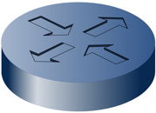 

Figure 1 The architecture of LAN in the lab

We write a script which does the request on the client side to the router to change the network then the network parameters are going to be set. Then the code load one of the pages which is located in our local server and then it measures the page load time and then die. The complete code has been implemented in java and it is also available in the appendix.

In the experiment there were 6 web pages that each of them has been loaded 10 times each (The list of webpages are available in the appendix). So, the statistics stored in an excel file which indicates 10 experiment for each page load and the network parameters have been set and the corresponding page load time.

One of the limitations I encountered during my data collection process was crashing. In fact, the Firefox crashed. The interesting point was it crashed at different points of time. First, I tried to approximate when it is going to crash again, but once it crashed after generating 11 .ser files but the next time it generates 60 .ser files and then crashed.

**Analysis and Results**

In the first glance there are some fundamental questions in analysis of the data.

* First, how different network parameters can provide better QoS?
* Second, was is the best approach to measure QoE with Page Load Time?
* Third, how to build the best QoS in terms of QoE by minimizing the cost?

There are so many approaches to measure QoE which are mentioned by the researchers. All of them cannot implacable; Bark Spectral Distortion (BSD), Perceptual Speech Quality Measure (PSQM), Video Quality Measurement (VQM) and poll based Mean Opinion Score (MOS) are some of them. BSD is used for measurement of audio data to incorporate the psychoacoustic responses. PSQM is used for measuring the quality of voice. VQM is used for video data quality measurement and MOS can be used for any kind of data and connection. In MOS we ask real clients to tell us about their experience through a survey.

Based on the the data we gathered, the following chart shows the relation between Page Load Time (PLT) and on of the QoS features which is Throughput.

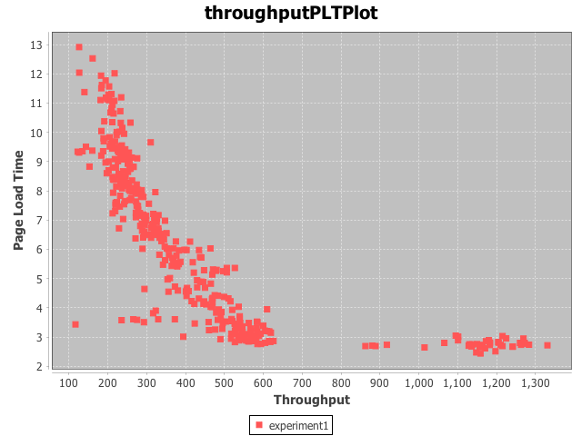

Figure 2 Illustrates the relation between PLT and Throughput

As it was predictable by increasing the throughput, PLT will decrease and the graphs approximately shows that the relation should be of exponential order but they are growing oppositely. We will get deeper into the exact formulation that express the relation of these two parameters later. Next chart illustrates the relation between PLT and Delay.

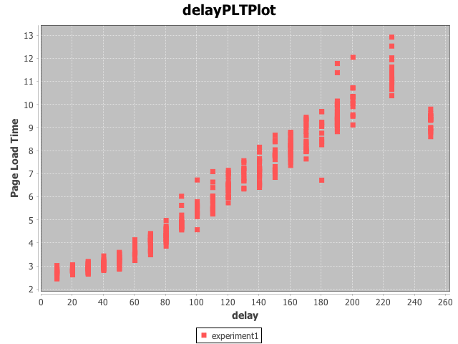

Figure 3 Illustrates the relation between PLT and Delay

Which appears reasonable that by increasing the delay the PLT will increase. But the point here is that for 1 specific amount of delay we experienced multiple different PLTs. This means that even if you do not change the delay the page load time will change, because it is affected by other metrics (throughput) too.

Next chart indicates the relation of page load time (QoE) with Throughput / delay (QoS). The higher the QoS the better the QoE.

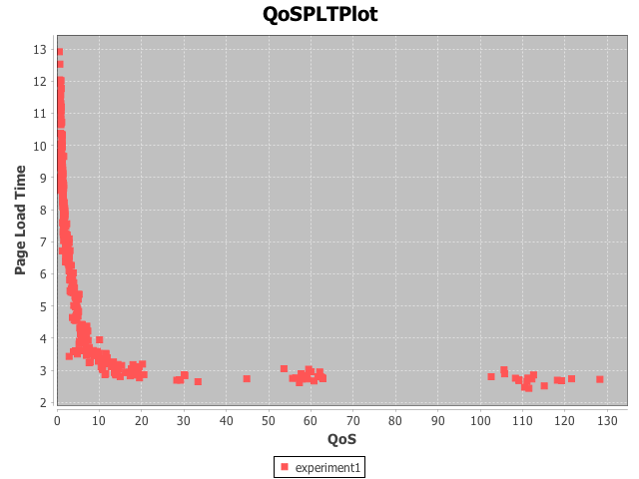

Figure 4 Illustrate how QoE and QoS are related

As it is interpretable from the graph, the higher the QoS the lower the page load time which means client should spend less time to load the webpage.

Now, let’s see the function which express the relation of QoE and QoS.

[5] $QoE= α∙e^{-β. QoS}+ Υ$

In this experiment we have 68400 iterations in which we change 3 QoS parameters so we have 68400 sets of (Delay, Loss, Throughput). By using a exponential regression calculator we can find α and β. We found the following values for each of them: [6]

α = 7.474315058

β = 1.415523842 * 10-2

Figure 5 shows the Heat Map reflecting page load time based on network parameters.

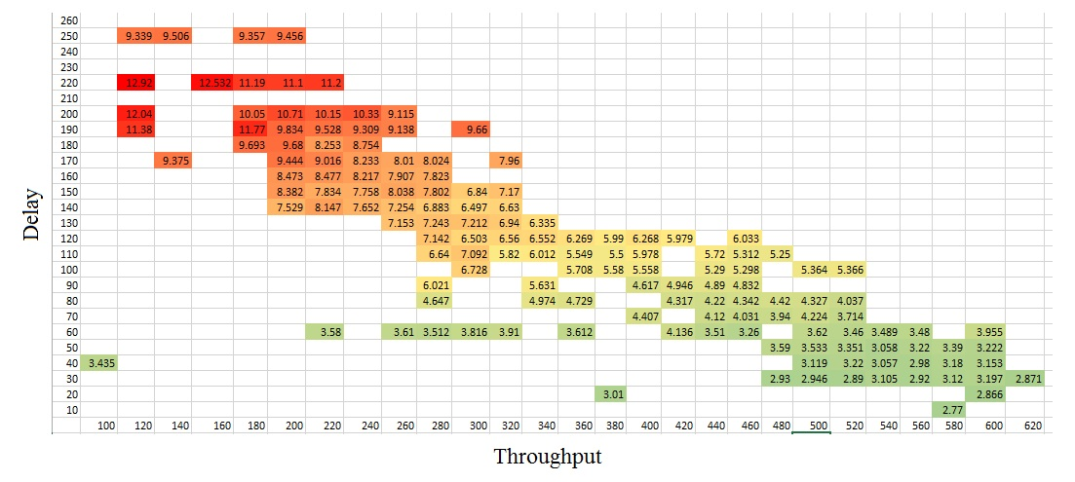

Figure 5 Illustrates the Heat Map reflectig how QoE is affected by QoS metrics

Beside all the points we figure out so far about the connection between QoE and QoS, the above figure has an important point which proves that the importance of delay is even more than the throughput because if you see in the Heat Map there is one green point (with reasonable PLT) that the network has the lowest throughput but the delay set to be little. By this observation we can interpret that delay has more priority that throughput.

**conclusion and future work**

Future studies can work on making the current model more accurate and also extend the model to perform more experiments on different web pages. We should also take this point under consideration that in the current model we have just 1 client to load the web pages and the server was like a private server for the client’s requests. Though we know that servers are almost always busy responding to different queries. This might make a huge difference in the results. Delay would be affected also, we might have some interferences and so packet loss, also network may reduce the throughput as well. Furthermore, the limitation that we faced during the data collection phase is going to make the situation harder if we deal with more data. So we may need more optimized way of programming and also be more aware of memory and other resources we are using. The program That we wrote was O(n5), It would be better to reduce the complexity of the program.

There are other interesting meanwhile challenging research areas in video streams. In these kinds of experiments, we deal with more metrics and also more QoE measurements can be done. So, the verification would be more challenging but the results are more interesting.

In this study we could exploit machine learning algorithms for measuring QoE. Since, by monitoring a set of client’s behaviors, it is possible to guess if he is satisfied with the connection. User interactivity of the program can be a sign of user task completion. Many researches have been done that verified the number of clicks from an end user [4]. Also, the application of these algorithms are extremely outstanding in observing video data. Even the signals of the speech of clients can show many signs. Machine learning algorithms can do the measurements based on these signs.

The other challenge is that the model that represents the QoE changes a lot over time. Since, the definition of clients of a good service varies a lot and also the expectations are always increase. In case of video data, the limitation is that there is no ground truth to define a connection as a satisfactory service, since there are more factors involved in a reasonable connection for users. A user might consider the resolution of the video; others might just care about the sound or one may be sensitive to delays or speed. The problem has also a psychological aspect which we should not neglect.

Other limitation that should be think of is hardware and software limitations on client’s computer which may impact the connection as well as network parameters. It has been approved that still the connection speed is much further than the mobile devices CPU computation time.

**Reference**

[1] Fiedler M., From QoS to QoE- Position Statement, Abstract Collection, From Quality of Service to Quality of Experience, Dagstuhl Seminar,2009

[2] Hestnes B., Brooks P., Heiestad S. et al, Quality of Experience in real-time person-person communication- user based QoS expressed in technical network QoS terms, 19th International Symposium on Human Factors in Telecommunication, Berlin,Germany, December 1-4 2003

[3] Quality of experience for mobile video users, Dialogic Making innovation thrive, white paper

[4] D. Soldani, M. Li and R. Cuny (Ed.), QoS and QoE Management in UMTS Cellular Systems. John Wiley & Sons, 2006

[5] SURVEY ON QOE\QOS CORRELATION MODELS FOR MULTIMEDIA SERVICES. Mohammed Alreshoodi

and John Woods, International Journal of Distributed and Parallel Systems (IJDPS) Vol.4, No.3, May 2013

[6] URL: <http://www.xuru.org/rt/ExpR.asp>

[7] Modeling Web Quality-of-Experience on Cellular Networks

**Appendix**

**All the codes are push to the git repository** [**https://github.com/FahimehMirhaj/QoSQoE.git**](https://github.com/FahimehMirhaj/QoSQoE.git)

**list of webpages**

The webpages are at:

1. <http://wings.cs.stonybrook.edu/courses/cse570/flipkart/>

2. <http://wings.cs.stonybrook.edu/courses/cse570/cnn/>

3. <http://wings.cs.stonybrook.edu/courses/cse570/nytimes/>

4. <http://wings.cs.stonybrook.edu/courses/cse570/bbc/>

5. <http://wings.cs.stonybrook.edu/courses/cse570/indiatimes/>

6. <http://wings.cs.stonybrook.edu/courses/cse570/bloomberg/>

https://ssl.gstatic.com/ui/v1/icons/mail/images/cleardot.gif